**Module 4: VPC Assignment – 3**

1. Created a VPC

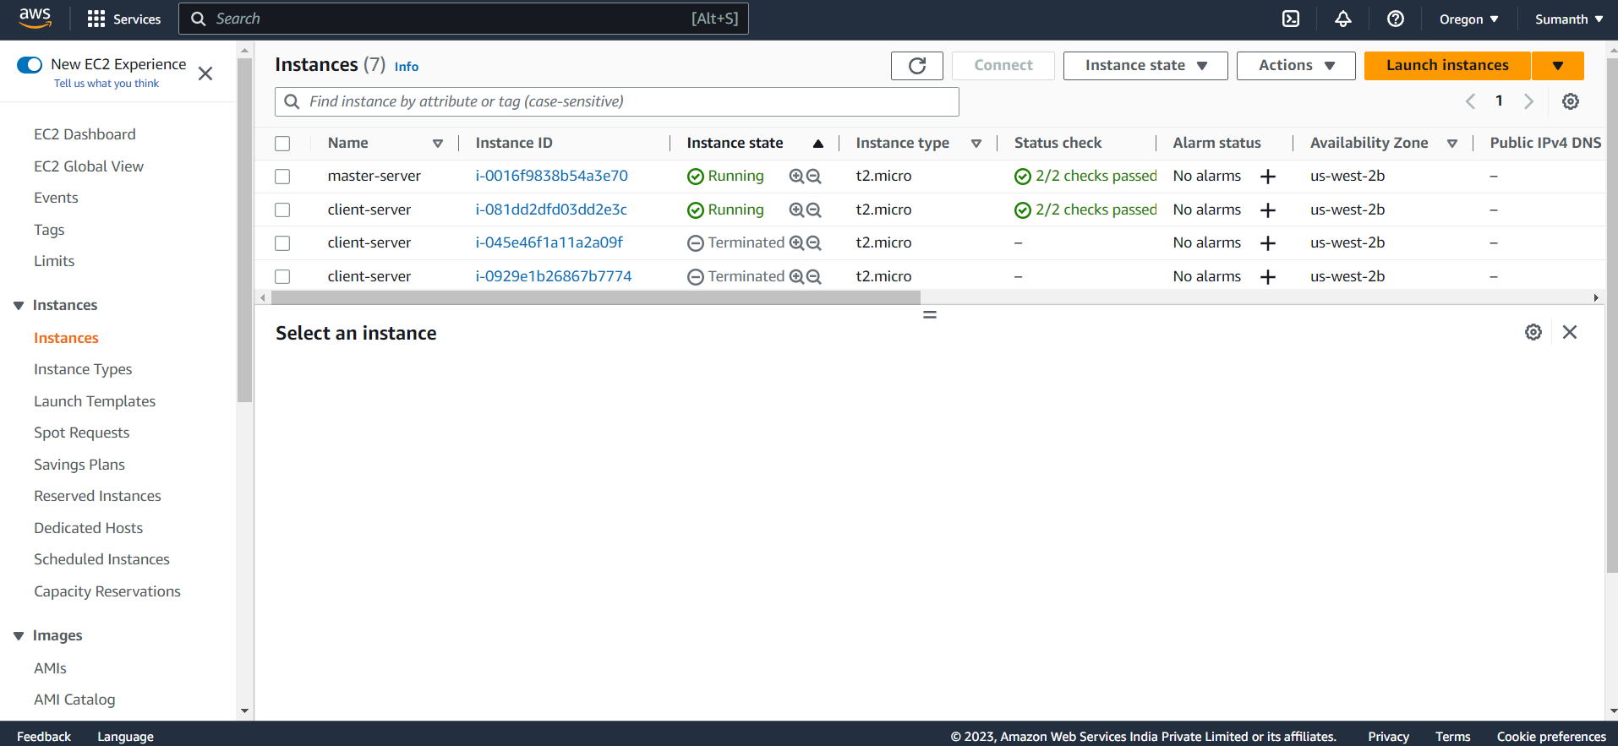

1. Created public subnet

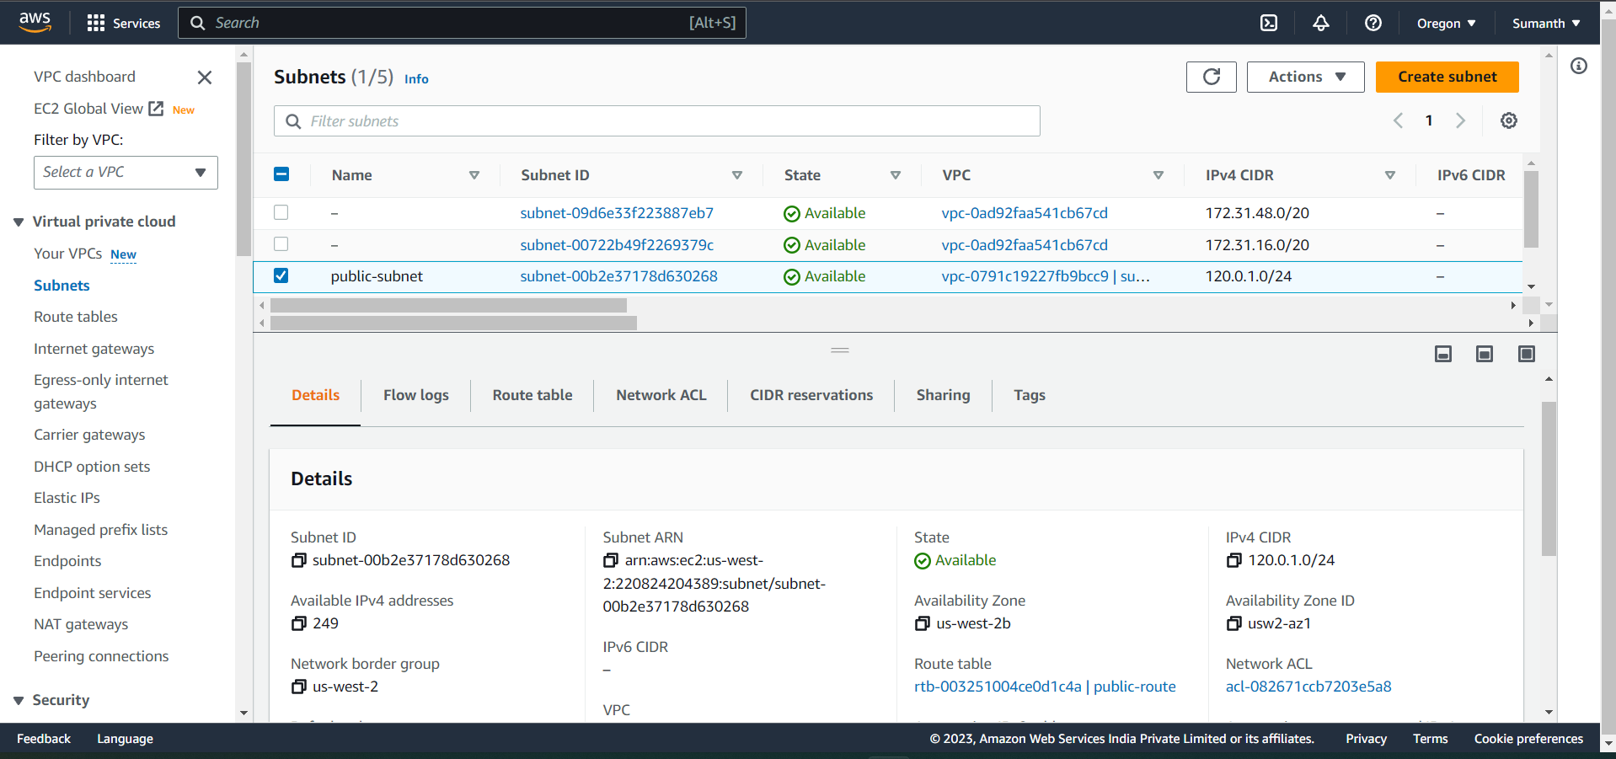

1. Created route table with IGW and associated with public subnet

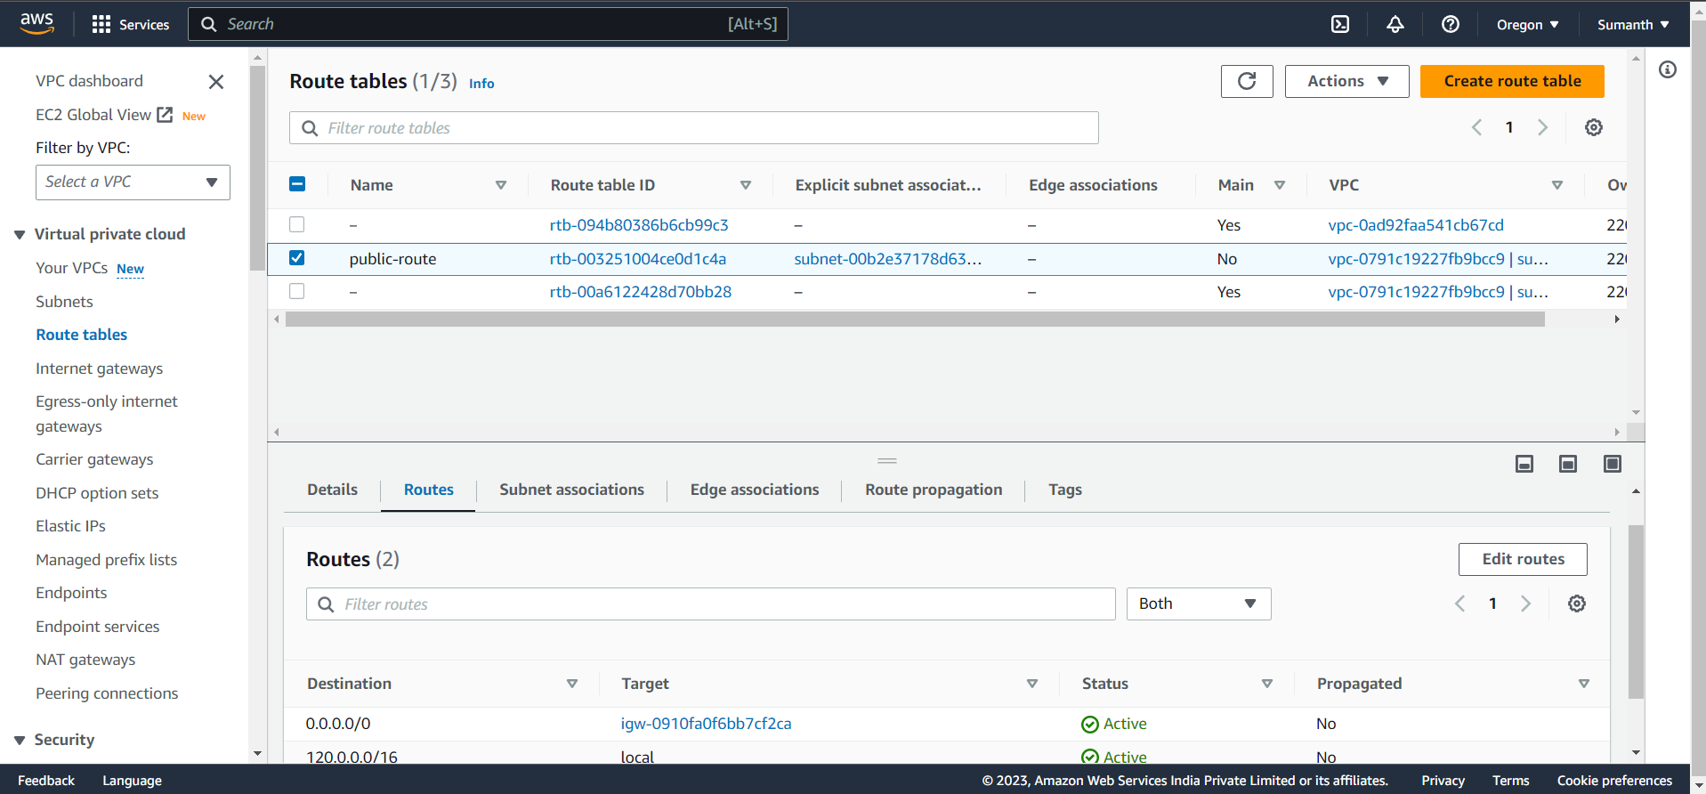

1. Created two EC2 instances

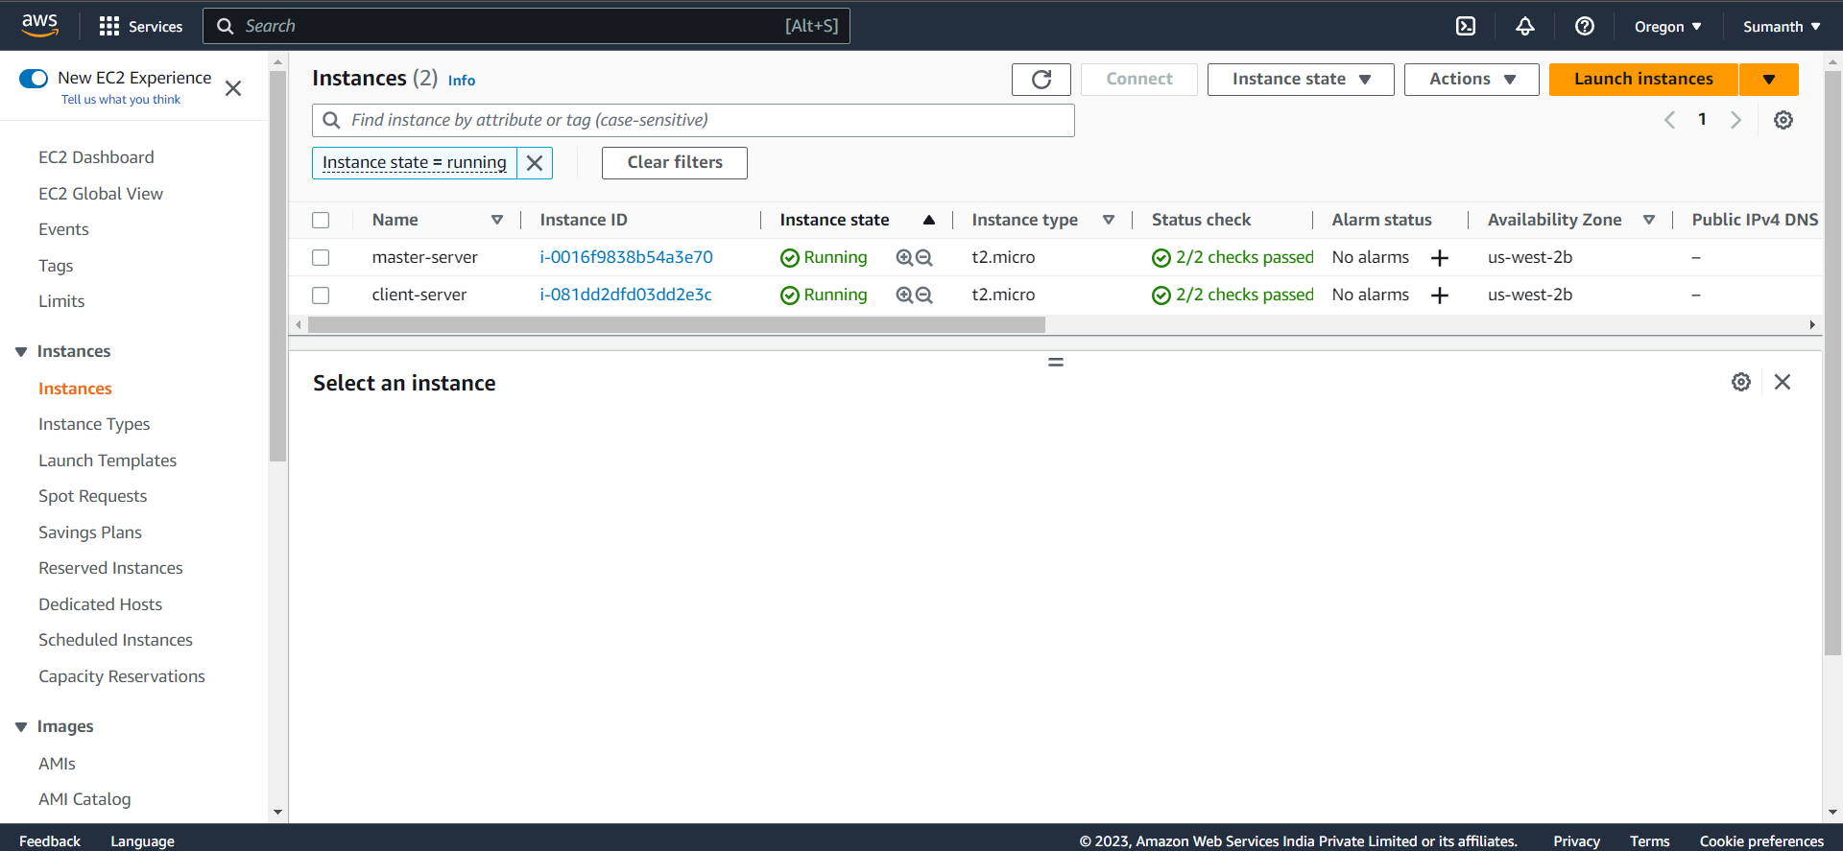

1. Client instance only being accessed through Master instance

